**Collecting Product Requirements**

The **Collect Requirements** process according to the **Project Management Body of Knowledge (PMBOK)** is *“the Process of determining, documenting and managing* ***Stakeholder*** *needs and requirements to meet Project objectives.”*

* Serves as foundation for defining and managing **Project** and **Product Scope**.
* Understanding **Project Requirements** is arguably the most important part of all **Project Management**.
* **Automobile Requirements**; great execution on the wrong requirements/portion of requirements leads to **Disaster**. Failing to meet unknown undocumented **Requirements** is also a **Disaster**.
  + Excellent fuel economy.
  + Space for at least 4 passengers.
  + Sub $25K price.

**Collecting Requirements** requires a high level of **Stakeholder Involvement** with discovery of needs and formalization of needs into **Requirements**. Care must be taken in determining, documenting and managing **Requirements**.

**Needs vs. Requirements**

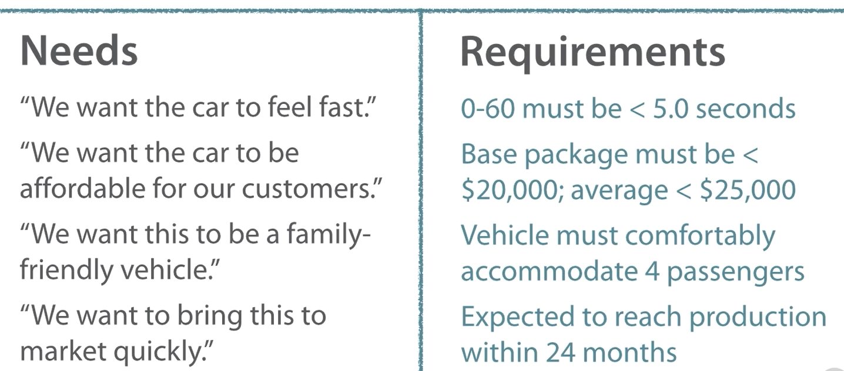

***Figure 7: Needs vs. Requirements***

**Requirements** are quantified and documented needs and expectations of the **Project Sponsor**, **Customer** and the key **Stakeholders**.

* Are conditions or capabilities that fulfill an **Agreement** or align with a formally declared **Specification**.
* Must be understood and documented at a high enough level of detail to be included in the **Scope Baseline** and used of control measurements.

**Requirements** are the foundation of the **Work Breakdown Structure (WBS)**. Many factors are affected by the way **Scope** is determined and described:

* **Cost Baseline****.**
* **Project Schedule.**
* **Quality.**
* **Planning Package****.**
* **Procurement Statement of Work (PSOW)****.**

**Types of Project Requirements**

The **Business Requirements** focus on **Stakeholder Needs** while **Technical Requirements** focus on how to fulfill **Stakeholder Requirements**. Types of **Requirements** include:

**Business Requirements** – describe **Organization’s** higher level needs in terms of **Strategic Opportunities**, purpose of the **Project**, and **Business Value**, for example:

* “We must develop a **Product** that reverses our course of ceding **Market Share** to the competition.”
* “There’s an opportunity to expand our **Services** into a new international **Market** and grow the **Business**.”
* “We must improve our call center’s productivity via new **IT Development** so as to improve **Customer Satisfaction** and lower costs.”

**Stakeholder Requirements** – describe needs of key **Stakeholders** of key **Stakeholder Groups**:

* “**Marketing** needs a **Prototype** for debut in six months.”
* “**Sales** wants us to leave enough margin for a negotiated discount from the initial **Proposal**.”
* “**Legal** wants to make sure we steer well clear of these **Regulatory** areas.”

**Functional Requirements** – characteristics and features of the end **Product**, **Solution** or **Project** result:

* “The **Device** must be able to connect to the newest **802.11 Standard networks**.”
* “We expect the final **Product** to weigh less than one pound.”
* “A **Screen** no smaller than 9.7 inches measured diagonally must be used in the final product.”

**Nonfunctional Requirements** – **Environmental Conditions** or **Qualities** that must exist for the **Functional Requirements** to be effective.

* “**Device Battery Life** must be at least six hours under rigorous use.”
* “The **Product** must use high quality materials that can withstand normal use over several years.”
* “The **Product** must be safe for use by all ages.”

**Transition Requirements** – any training, conversion or improvement activities that must occur in order to be ready for the **Project’s Result**.

* “**Support Staff** must be effectively trained in how to use the new **Platform** before **Delivery** is considered complete.”
* “A new **Manufacturing Facility** must be completed before **Operations** can move the end result into **Production**.”
* “We must convert our old **Data Archives** to a new format before most **Project Work** can begin in earnest.”

**Project Requirements** – actions, processes or other **Conditions** imposed on the **Project**:

* “We can only spare two **Members** of our **Department** for the **Project**.”
* “We need to leverage existing integral **Forms** and **Processes** for our integrated **Change Control System**.”
* “The **PMO** must be given weekly updates on **Project Status**.”

**Quality** **Requirements** – **Validation Conditions** and **Criteria** to confirm successful fulfillment of **Project Requirements**:

* “The **Manufacturing Process** must result in an unresolvable **Defect Rate** no higher than 0.001%.”
* “**Product Performance** as benchmarked must meet this full list of **Technical Requirements**.”
* “**Servers** must be able to withstand large spikes in active **User Count**.”

**Gaining Requirements from Others**

**Interviews** may be formal or informal, one on one or involving several **Parties**.

* Spontaneous and prepared **Questions**.
* Aids in identifying and defining features and **Functions** of **Deliverables**.
* Good for gaining **Confidential Information**.

**Focus Groups** are where a trained **Moderator** leads a conversational, participatory discussion.

* Brings together key **Stakeholders** and **Subject Matter Experts (SMEs)**.
* Learn about expectations and attitudes related to proposed **Project** and its result.

Facilitated **Workshops** are sessions with key **Stakeholders** focused on defining **Product Requirements**, and are an efficient way to…..

* Define **Cross Functional Requirements**.
* Quickly identify and reconcile **Conflicts**.
* Useful in building **Trust**, fostering **Relationships** and improving **Communications**.
* Helps **Project Teams** discover issues and potential **Risks** more quickly.
* **Joint Application Design/Development (JAD)** – brings business **SMEs** together with **Development Team**. Improves **Development Process** by ensuring the right work is done.
* **Quality Function Deployment (QFD)** collects **Customer Needs**, presented as the **Voice of the Customer**. **User Stories** are developed to better describe needs in a narrative fashion.

**Brainstorming** is useful in generating **Requirements** and potential steps to define them. Doesn’t include **Voting** or **Prioritization**. Often combined with other techniques.

* **Nominal Group Technique** follows up brainstorming with a voting process that ranks ideas, prioritizing them for continued thought and refinement.
* **Idea/Mind Mapping** is where ideas from individual brainstorming sessions are consolidated into a visualization.
  + The Idea map reflects interrelations and differences, helps to generate further ideas.
* **Affinity Diagrams** filter ideas into groups to be reviewed and analyzed, placing similar ideas together for further consideration.
  + Can be useful in spotting potential synergies and determining the best of several similar options.
* **Multi Criteria Decision Analysis** is a matrix used to help establish Decision Criteria and evaluate/rank many ideas. Very analytical approach to decision making, focused on a variety of Formal criteria.
* **Decision Making** 
  + Majority Method requires at least 50% of voting Members to agree.
  + Plurality Method selects the most popular choice, even of not a majority.
  + Dictated outcome occurs when **Project Manager** or other individual makes a unilateral decision.

**Leveraging Data and Analytics**

**Questionnaires** **and** **Surveys** are good for quickly obtaining information and opinions from many participants.

* Best used with large, varied **Groups**.
* Useful when quick **Feedback** is needed.
* Valuable when **Statistical Analysis** is planned.

**Observations** are a direct way to observe workers, processes and environments that:

* Helpful when **Respondents** cannot or will not effectively explain a **Process** or **Circumstance** narratively.
* Can involve **Job Shadowing** or **Experiential Learning**.

**Prototypes** represent a working model of expected **Product** used for early **Feedback**. **Tangibility** allows for experimentation instead of only discussion.

* Highly useful in **Iterative Development**.
* **Storyboarding** is a kind of Prototyping.

**Benchmarking** compares **Results** or **Practices** to expected **Results** or **Practices**.

* Plans or competitive comparisons often used as a Baseline for comparison.
* External or internal points of comparison may be used.

**Context Diagrams**

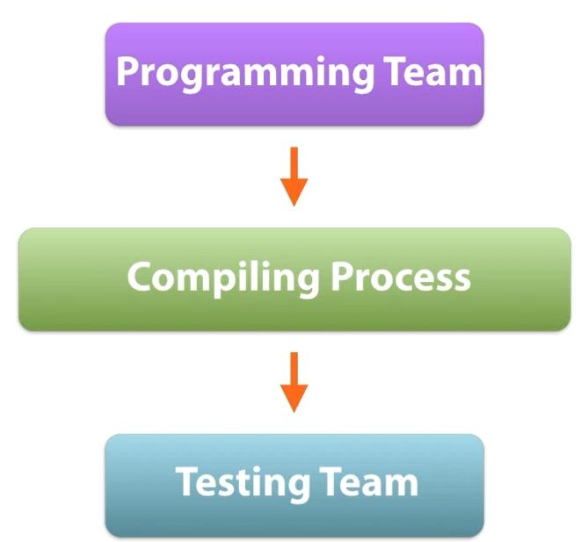

***Figure 8: Context Diagrams***

**Context Diagrams** visually depict **Product Scope** by relating a **Business System** to **People** and other **Systems**. Shows:

* **Inputs** to **System**.
* Who provides the **Input**?
* **System Output**.
* **Output Recipients**.

Analyzing existing **Documents** can also help in creating **Requirements** through:

* Business Plans
* Marketing literature
* Agreements
* **Request for Proposals (RFP)**
* **Logical** **Data Models**
* Business Rules
* **Application Documentation**
* Process/Interface documentation.
* Use cases
* Problem/Issue Logs
* **Policies** and **Procedures**.
* Regulatory documentation

**Requirements Traceability Matrix**

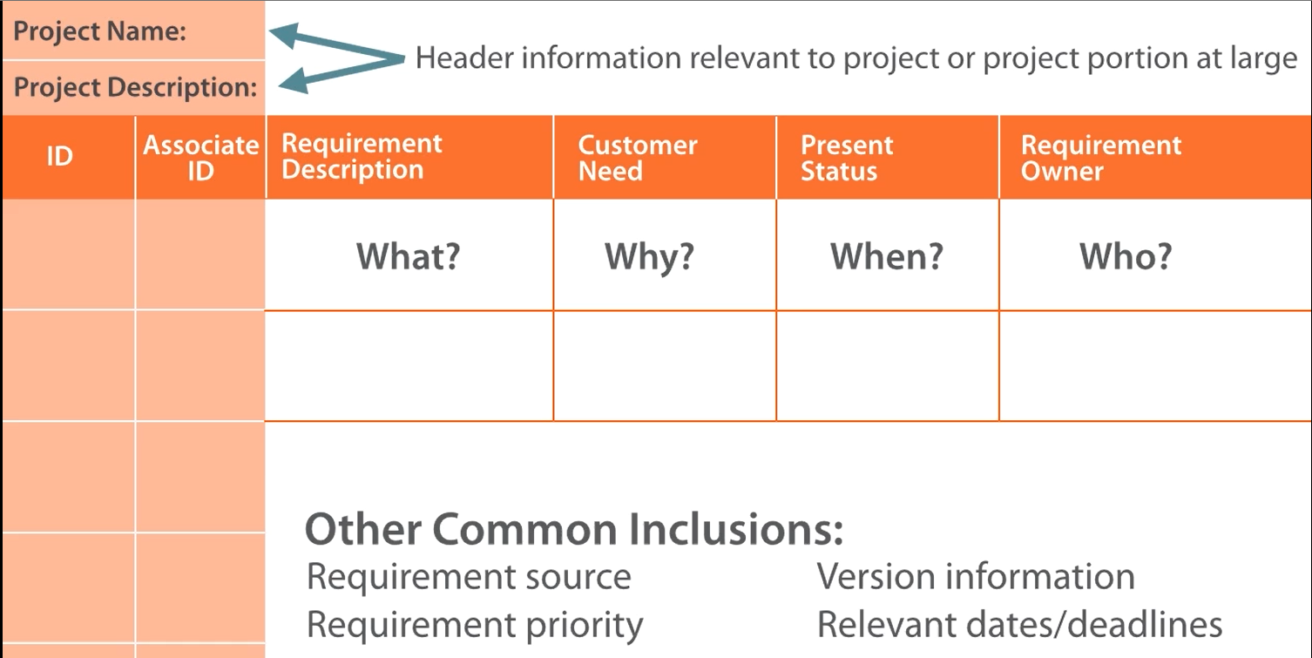

***Figure 9: Requirements Traceability Matrix***

A **Requirements Traceability Matrix** links **Business Objectives** to Project objectives. Tracking **Requirements** for the whole **Project Life Cycle**.

Identifying responsible **Stakeholders**.

Managing **Changes** to **Scope** by including:

* **Business Needs/Opportunities**.
* **Project Objectives**.
* Portions of **Project Scope** and **WBS Deliverables**.
* **Product Design.**
* **Product Development**.
* **Strategy** and **Scenario Testing**.
* **Requirements** at various levels of detail.